|  |  |
| --- | --- |
| **Title** | 1st homework in the Electric Circuit Theory class by 201923250 |

|  |  |  |  |
| --- | --- | --- | --- |
| **Author** | 201923250 | **Date** | 9.3.2020 |

**Summarization of sections from 7.1 to 7.4**

If a circuit is bound by a single inductor and has multiple resistors and dependent outlets, a single RL circuit is generated by the Thevenin equivalent at the terminals. Also, since many inducers can be combined to form a single equivalent inductor, one can use Thevenin 's theorem. If the output is specified, the time constant is the same. In order to be. If there is a single circuit The Thevenin counterpart can be located at the condenser terminals to form a basic RC circuit and multiple resistors and based sources.

The theorem of Thevenin is also possible where many capacitors can be merged into one similar condenser The normal reaction alone, without external references, depends on the design of the circuit. In fact, only the energy originally contained in the condenser will react to the circuit.

**Answers of all the examples from sections 7.1 to 7.4**

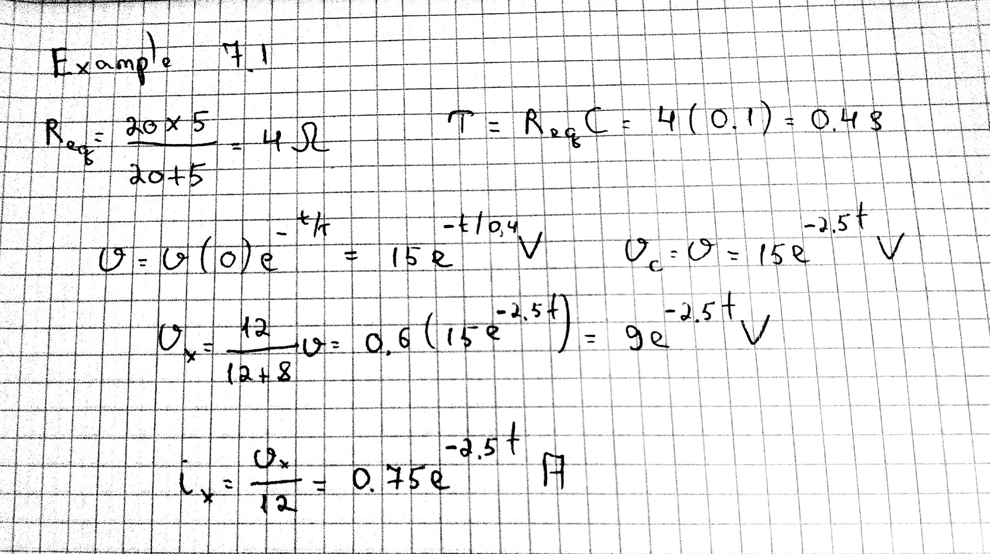

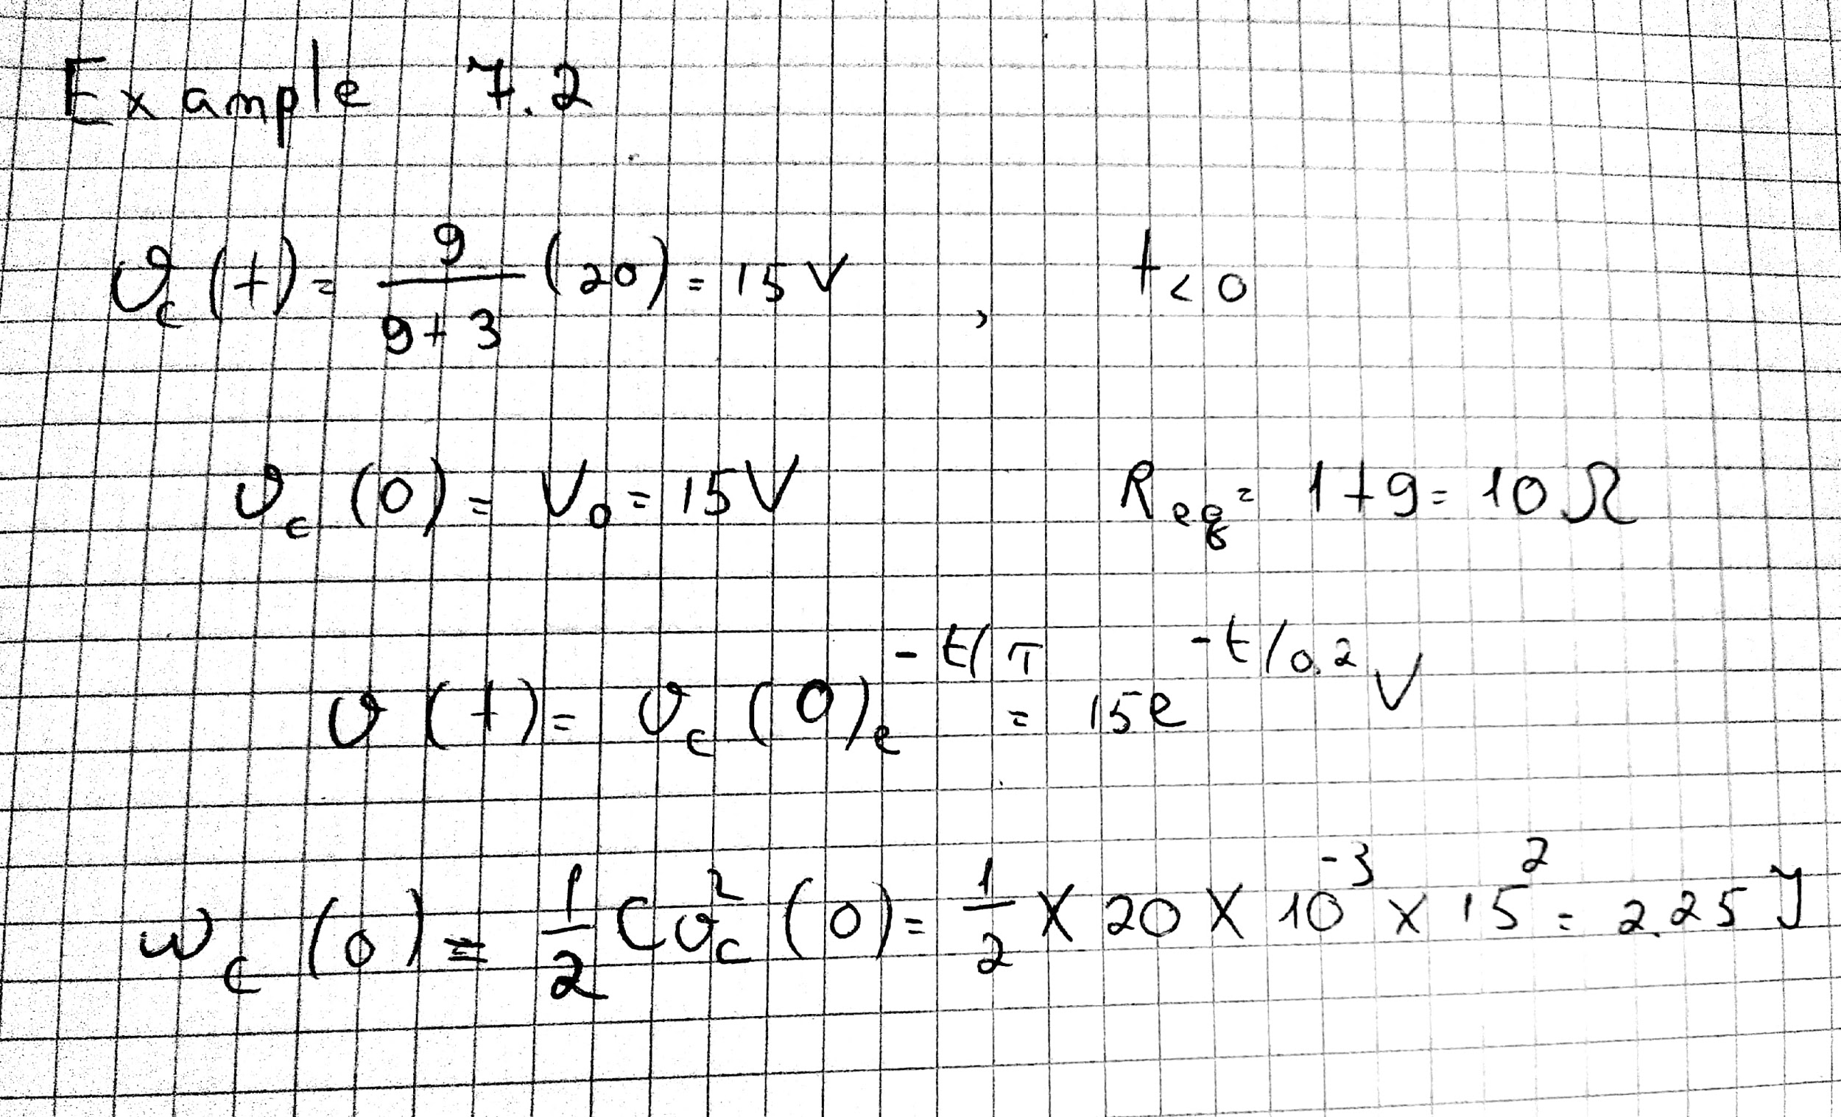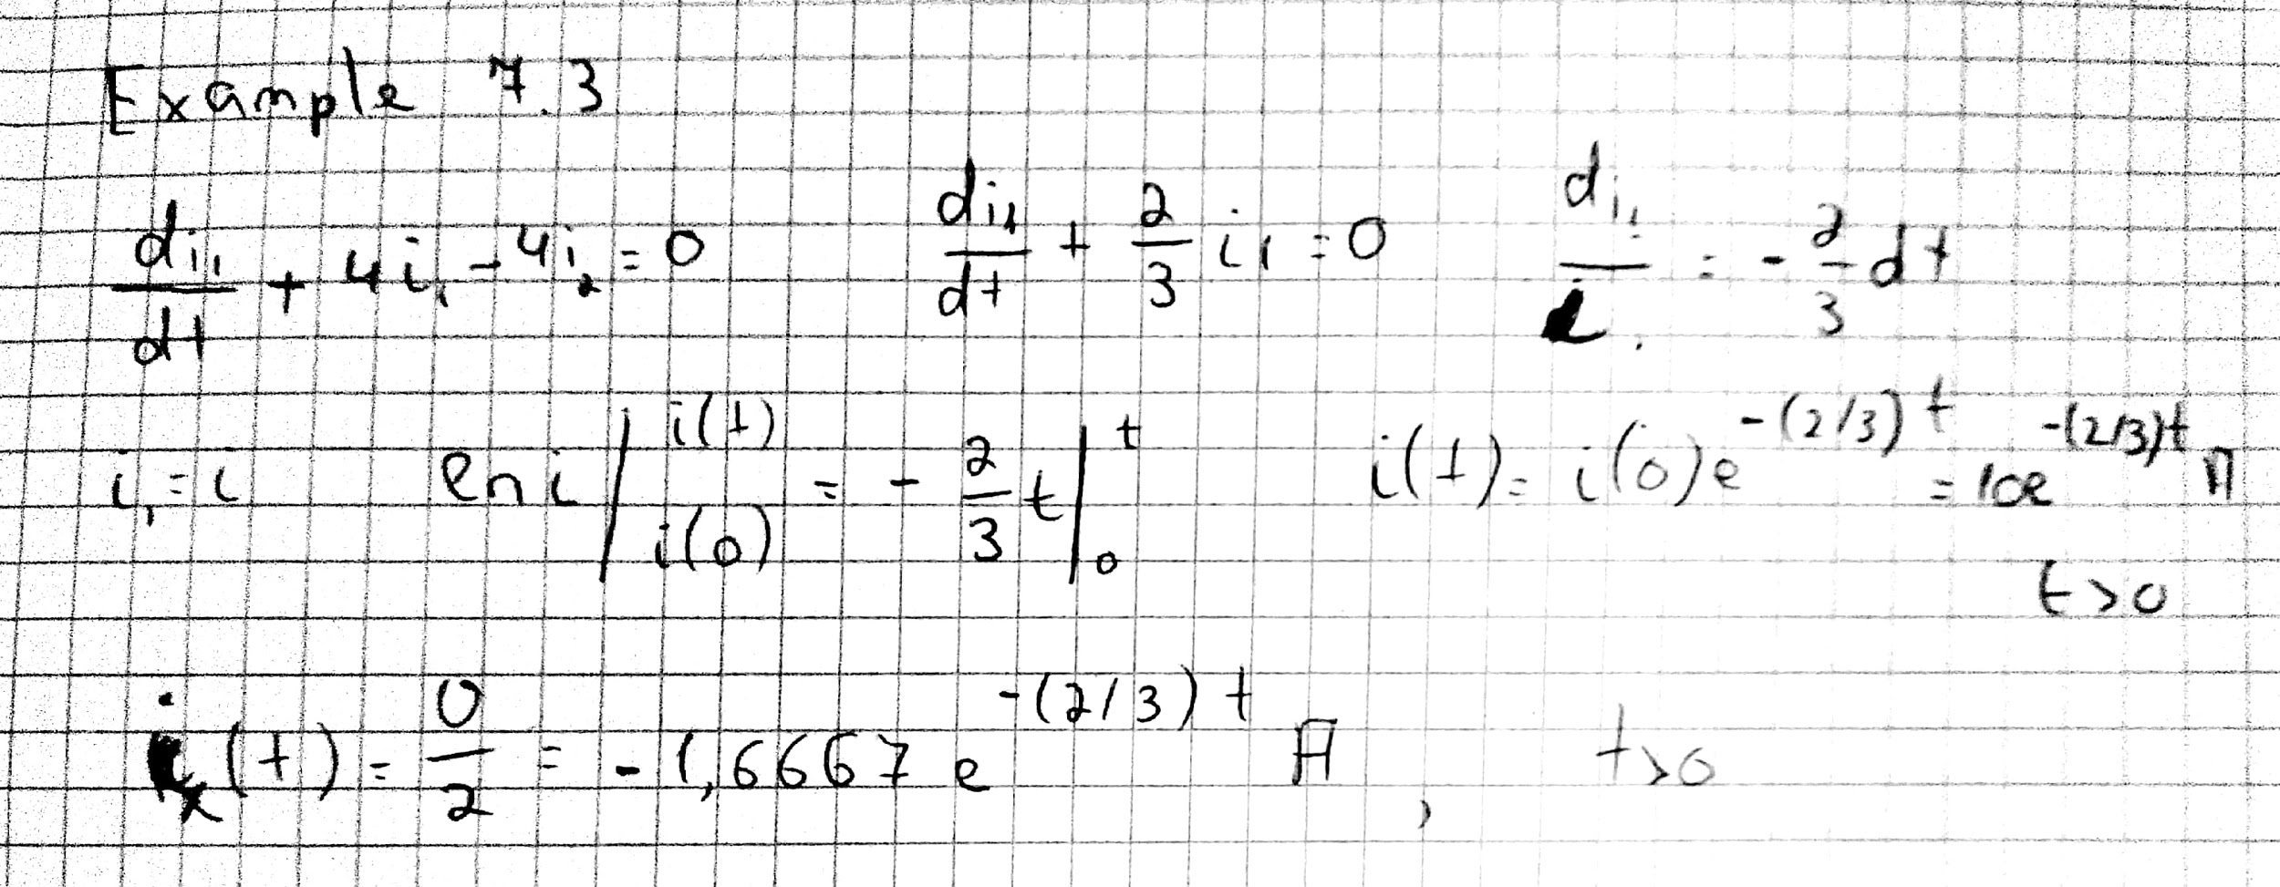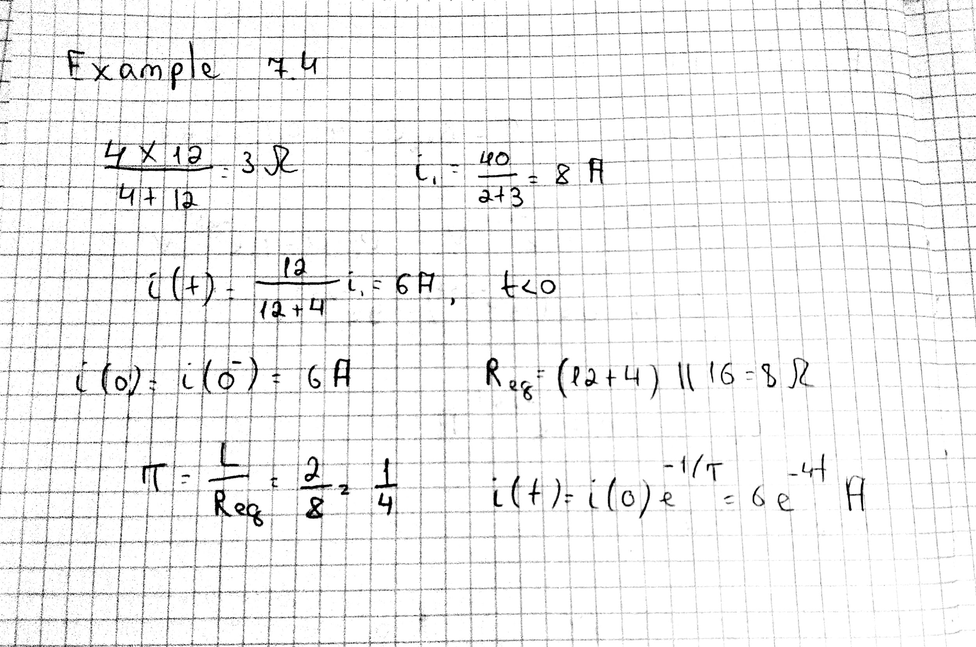

Thank you